**Part 0a: Significant between-area differences in perceptions on PHC functions** *(won’t be included in SEM)*

Health_Center_2 (less perceived need in major cities)



Health_Center_6 (less perceived need in major cities)



Health_Center_7 (more perceived need in medically underserved areas)



**Part 0b: Perceived need of transforming Public Health Centers into Community Health Centers focused only on disease prevention & health promotion services**



There is no significant difference between areas. It seems like PHC workers all across Taiwan, regardless of area, feel inclined to support a functional transformation of PHCs.

* If area is not the main determining predictor, then what factors influence this perception?

**Part 1: Exploratory Factor Analysis**

4 hypothesized latent factors:

test_fa <- df[, c("fatigue_01", "fatigue_02", "fatigue_03", "fatigue_04","fatigue_05", "Job_Burnout", "KPI_Stress", # stress-related

'Responsibility_Clarity', 'Workload_Reasonable', 'Authority_Understanding', 'Opinion_Expression', 'cowork_help',

'boss_flex', 'talk_boss', # working environment

'Health_Center_1', 'Health_Center_2', 'Health_Center_3', 'Health_Center_4', 'Health_Center_5', 'Health_Center_6', 'Health_Center_7', # PHC functions

"CareSystem", "Understand_CommunityNeeds", "TailoredServices", "ResourceIntegration", "BuildCommunityTrust",

"CooperationWithInstitutions", "CompetitionWithInstitutions" # external relations

)]

5 levels were suggested in the first screening:

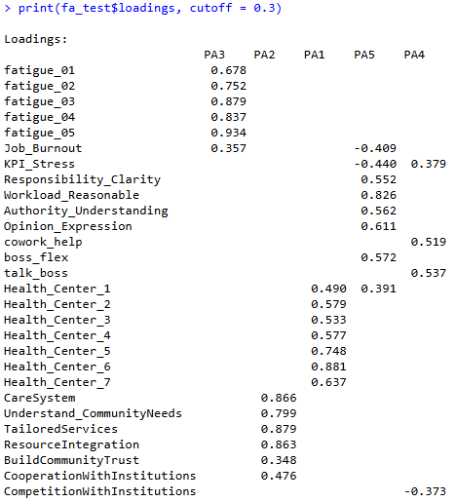

Remove variables that load to >1 factors (KPI_Stress, Job_Burnout, Health_Center_1). 4 levels were suggested.

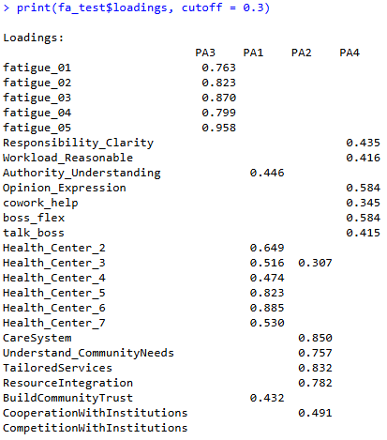

Remove variables that don't load to any factor (CompetitionWithInstitutions and later cowork_help)

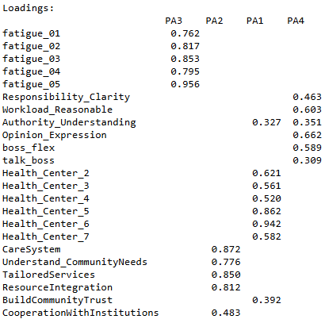

Remove the variable with the lowest loading (talk_boss)

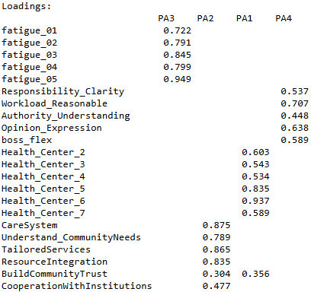

Remove the variable that load to >1 factors (BuildCommunityTrust)

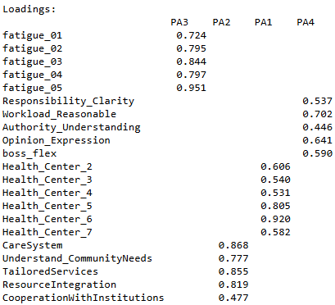

* Cleaned. We can use these latent factors to calculate alphas.

**Alphas**

|  |  |  |  |
| --- | --- | --- | --- |
| **Latent factor** | **Raw alpha** | **Recommendation** | **New alpha** |
| Fatigue | 0.9067 |  |  |
| Working Environment | 0.7125 | Drop boss_flex | 0.7396 |
| PHC Functions | 0.8309 |  |  |
| Community Participation | 0.8580 | Drop CooperationWithInstitutions | 0.8883 |
| All | 0.8718 (95% CI: 0.8225-0.8993) | | |

**Part 2: Confirmatory Factor Analysis**

cfa_model <- '

Working_Environment =~ Responsibility_Clarity + Workload_Reasonable + Authority_Understanding + Opinion_Expression

Fatigue =~ fatigue_01 + fatigue_02 + fatigue_03 + fatigue_04 + fatigue_05

PHC_task =~ Health_Center_2 + Health_Center_3 + Health_Center_4 + Health_Center_5 + Health_Center_6 + Health_Center_7

Community =~ Understand_CommunityNeeds + CareSystem + TailoredServices + ResourceIntegration

'

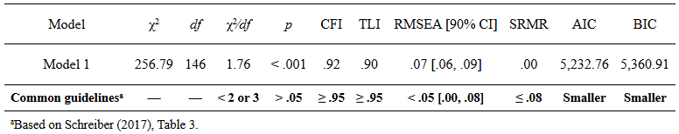

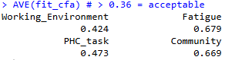

* Goodness of fit indicators and AVEs all look good. Proceed to SEM.

**Part 3: Structural Equation Modeling**

*Earlier steps are not included for conciseness. See R code for the full testing process.*

sem_test4 <- '

Working_Environment =~ Responsibility_Clarity + Workload_Reasonable + Authority_Understanding + Opinion_Expression

Fatigue =~ fatigue_01 + fatigue_02 + fatigue_03 + fatigue_04 + fatigue_05

PHC_task =~ Health_Center_2 + Health_Center_3 + Health_Center_4 + Health_Center_5 + Health_Center_6 + Health_Center_7

Community =~ Understand_CommunityNeeds + CareSystem + TailoredServices + ResourceIntegration

Fatigue ~ Working_Environment

PHC_task ~ Working_Environment + Fatigue

TransformToHealthCenter ~ PHC_task + Community

PHC_task ~~ Community

Community ~~ Fatigue

'

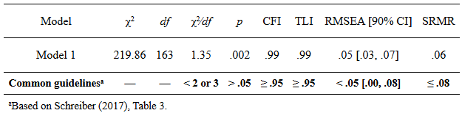

*(may need to recheck, nice_fit fetches standard values, but we might want to refer to the scaled values 🡪 for discussion)*

